StudyMate AI – An Agentic AI-Powered Personalized Academic
Study Assistant

PROJECT REPORT FOR THE COURSE
AD23731 FOUNDATIONS OF AGENTIC AI

Submitted by

TARUN AANAND S G (Reg. No. 231501172)
TARUN A D (Reg. No. 231501171)
SAI SENTHIL M (Reg. No. 231501140)



DEPARTMENT OF
ARTIFICIAL INTELLIGENCE AND MACHINE LEARNING RAJALAKSHMI ENGINEERING COLLEGE
THANDALAM, CHENNAI, 602105



BONAFIDE CERTIFICATE

Certified that this is a Bonafide Record of the project work done by TARUN AANAND S G (231501172), TARUN A D (231501171) and SAI SENTHIL M (231501140) of VII Semester, B.Tech. Artificial Intelligence and Machine Learning Department in partial fulfilment of the requirements of the course AD23731 – Foundations of Agentic AI during the Academic Year 2026 – 2027.

Faculty in-charge

Submitted for the Project Review held on: ………………………

INTERNAL EXAMINER EXTERNAL EXAMINER
Table of Contents
1. INTRODUCTION 1
1.1 Background and Motivation 1
1.2 Need for Agentic AI 1
1.3 Project Objectives 1
2. PROBLEM STATEMENT AND BUSINESS CASE 2
2.1 Problem Definition 2
2.2 Business and Real-World Context 2
2.3 Business Case 3
3. USER AND STAKEHOLDER ANALYSIS 3
3.1 Target Users 3
3.2 Stakeholder Identification 3
3.3 User Requirements 4
4. PROPOSED AGENTIC AI SOLUTION 4
4.1 Overall Solution 4
4.2 Key Features 5
4.3 Agent-Based Approach 5
5. DATASET / KNOWLEDGE SOURCES 6
5.1 Student-Provided Course Materials 6
5.2 Synthetic Evaluation Knowledge Source 6
5.3 Knowledge-Source Processing 6
5.4 Dataset / Knowledge-Source Limitation 7
6. TOOLS AND TECHNOLOGIES USED 7
7. AGENT ARCHITECTURE 8
7.1 Agent Components 8
7.2 Tools 8
7.3 Memory and State 8
7.4 Reasoning Flow 8
7.5 Agent Interactions 8
8. AGENT WORKFLOW AND ORCHESTRATION 8
8.1 Workflow Design 8
8.2 Task Decomposition 9
8.3 Agent Coordination 9
8.4 Orchestration Implementation 9
9. AGENTIC RAG IMPLEMENTATION 10
9.1 Retrieval Architecture 10
9.2 Knowledge Retrieval 10
9.3 Generation Process 11
9.4 Critique and Grounding Check 11
9.5 Retrieval-Quality Evaluation 11
10. SYSTEM IMPLEMENTATION 11
10.1 Functional Prototype 11
10.2 AI Advisor and Materials 11
10.3 Profile, Progress and Memory 12
10.4 Study Planner and Quiz 12
10.5 Source-Code Repository 12
10.6 Interface Representation 12
11. EXPERIMENTAL EVALUATION AND RESULTS 13
11.1 Evaluation Metrics 13
11.2 Testing Methodology 13
11.3 Performance and Functional Results 14
11.4 Success-Metric Achievement 14
12. COMPARISON, INNOVATION AND SCALABILITY 15
12.1 Comparison with Baseline 15
12.2 Advantages of the Proposed System 15
12.3 Innovation 16
12.4 Scalability 16
12.5 Real-World Applicability 16
13. CONCLUSION AND FUTURE WORK 16
13.1 Conclusion 16
13.2 Future Work 17
REFERENCES 17

List of Tables
Table 1. Stakeholder Analysis 3
Table 2. User Requirements 4
Table 3. Key Features of StudyMate AI 5
Table 4. Tools and Technologies Used 7
Table 5. Agent Components 8
Table 6. Task Decomposition Stages 9
Table 7. Retrieval Configuration 6
Table 8. Evaluation Metrics 11
Table 9. Functional Test Cases 13
Table 10. Evaluation Run Template 14
Table 11. Baseline Comparison 15
Table 12. Advantages of the Proposed System 15
Table 13. Project Limitations 16
Table 14. Future-Work Priorities 17

List of Figures
Figure 1. Overall System Architecture 2
Figure 2. Major Application Modules 4
Figure 3. Agentic Advisor Workflow 5
Figure 4. Agentic RAG Retrieval Pipeline 6
Figure 5. Student Memory and Personalization Flow 7
Figure 6. Quiz Generation and Evaluation Workflow 10
Figure 7. Study Planner with Human Approval 10
Figure 8. Evaluation Design 14
Figure 9. Representative Streamlit Interface Layout 12
Figure 10. Source-Code Repository Structure 13
Figure 11. Data Flow and Context Assembly 15

1. INTRODUCTION

1.1 Background and Motivation
The rapid adoption of Generative Artificial Intelligence has created new opportunities for improving the way students search for information, understand concepts, practice questions, and organize their learning. Large Language Models can generate explanations and interactive responses in natural language, making them attractive for academic support. However, a general-purpose language model does not automatically know the exact material taught in a particular course, the student's current progress, or the topics that require additional attention.
StudyMate AI is designed as a personalized academic study assistant that brings these capabilities together in one Streamlit application. The system can communicate with a Groq-hosted language model, retrieve information from student-uploaded PDF, TXT, and Markdown course material, store profile and academic progress information locally in SQLite, generate practice quizzes, and create study-plan drafts. The repository organizes these capabilities into focused modules and uses LangGraph state graphs to coordinate the advisor and quiz workflows.
The motivation for the project is therefore twofold. First, it addresses a practical learning problem: students spend time switching between notes, search tools, chat interfaces, quiz applications, and planning tools. Second, it provides a concrete software implementation through which Agentic AI concepts can be demonstrated. Instead of using the language model as a single response generator, StudyMate AI places it inside a controlled workflow involving query planning, local retrieval, answer generation, and optional criticism of the generated answer.

1.2 Need for Agentic AI
A conventional chatbot can be represented as a simple linear interaction in which a question is directly sent to an LLM and a response is returned. This structure is useful for broad questions but is less suitable when a student expects the answer to reflect uploaded course material and personal context. A more useful educational assistant needs to decide when retrieval is necessary, retrieve supporting information, combine that information with the conversation and student context, and, when requested, inspect the generated answer before it is finalized.
Student Question → LLM → Answer
StudyMate AI introduces an agentic alternative. In Agentic retrieval + critic mode, the application first asks Groq to propose up to three short alternative lexical search queries. The local retrieval layer then searches indexed chunks, ranks the results, and keeps the best matches. The LLM produces a draft answer using the conversation, student context, and retrieved excerpts. A separate critic prompt can then classify the answer as supported, revised, or insufficient and provide a revised response when necessary. This sequence is implemented as a LangGraph state graph with explicit nodes and conditional routing.
Question → Plan Searches → Retrieve Chunks → Draft Answer → Critique → Final Response
The agentic design is not intended to make the system fully autonomous. Instead, it provides structured control over the sequence of actions performed around the LLM. This is particularly valuable for educational use because the system can expose which sources were used, distinguish a close document match from general-knowledge answering, and maintain a clear separation between data retrieval, generation, and application logic.

1.3 Project Objectives
The main objective of StudyMate AI is to develop a practical academic assistant that demonstrates the integration of Generative AI, Retrieval-Augmented Generation, agentic workflow orchestration, personalization, and interactive study support.
• Provide a conversational AI advisor for academic explanations and study guidance.
• Allow students to upload course materials in PDF, TXT, and Markdown formats and make the extracted text searchable.
• Implement local TF-IDF cosine-similarity retrieval as a lightweight RAG mechanism.
• Implement Agentic RAG using query planning and answer criticism through LangGraph and Groq.
• Use locally stored student profile, learning preferences, advisor memory, subject progress, and focus topics to personalize responses.
• Generate topic-based multiple-choice quizzes and validate their structured output before local scoring.
• Provide an AI-assisted study planner that requires explicit student approval before saving a plan.
• Provide a synthetic evaluation harness comparing no RAG, basic RAG, and agentic RAG modes.
• Keep API configuration, retrieval, persistence, workflow, and interface responsibilities separated into maintainable Python modules.
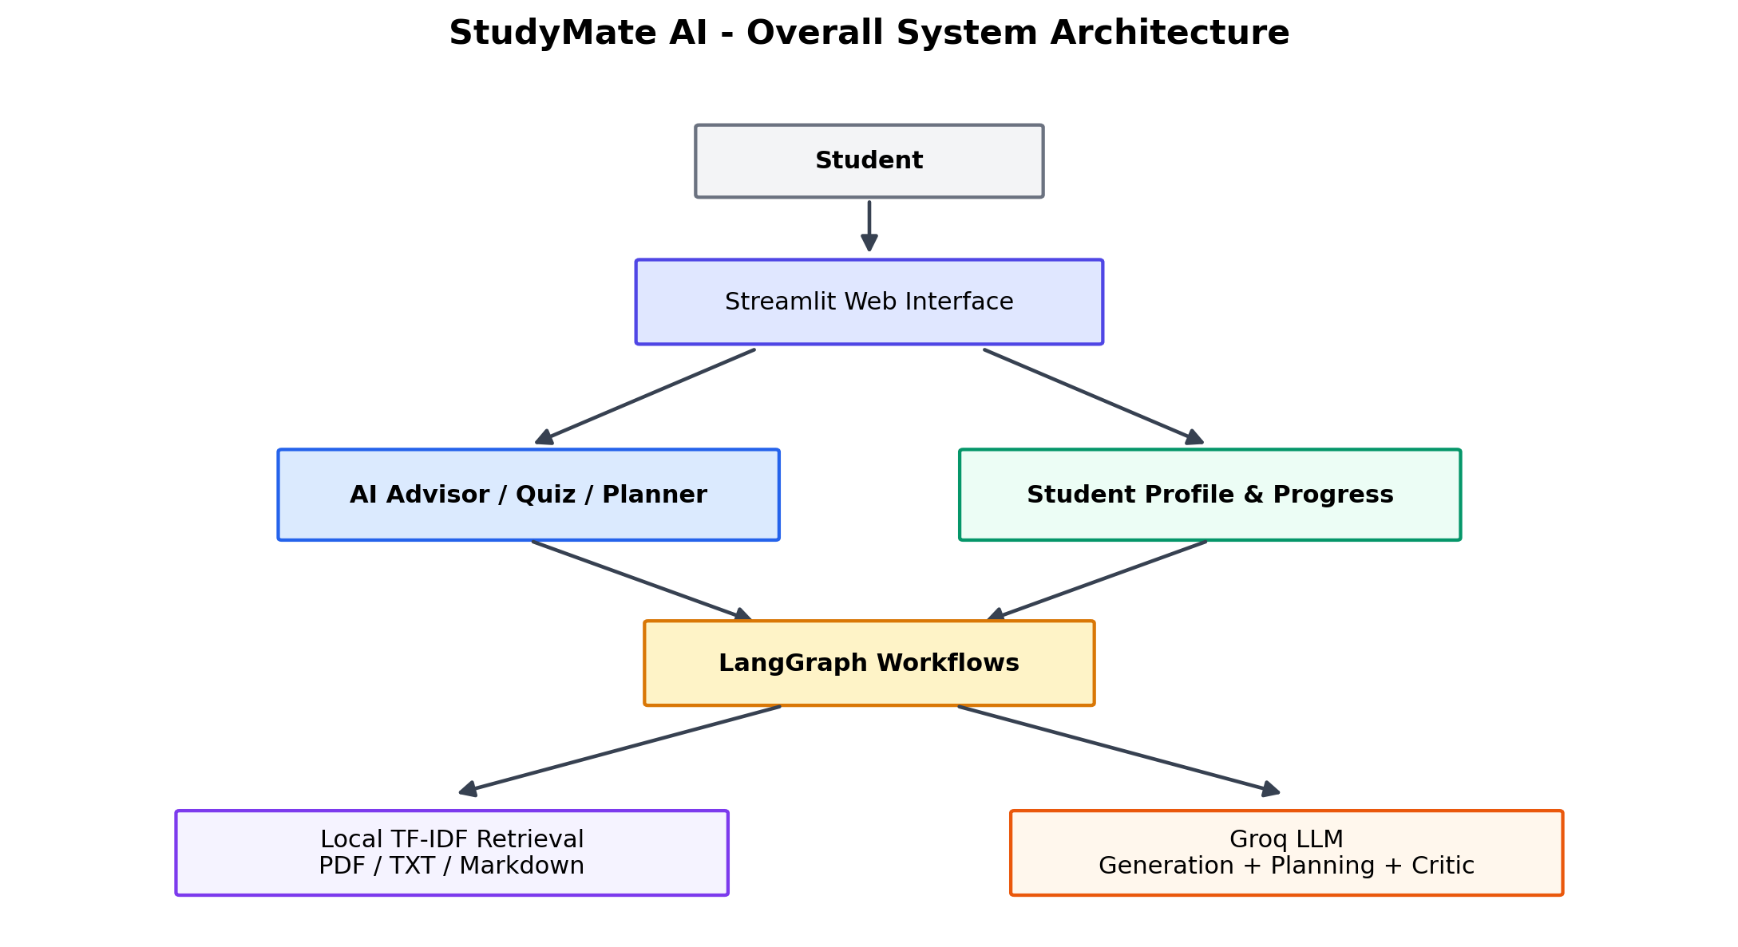
Figure 1. Overall System Architecture

2. PROBLEM STATEMENT AND BUSINESS CASE

2.1 Problem Definition
Students often have access to large collections of lecture notes, textbooks, slides, and assignment references, but the information is fragmented across files and applications. When a student has a question, the student may need to search the relevant document, identify the correct passage, interpret the material, and then organize the result into a useful explanation. Generic LLM chat can reduce the effort involved in explanation, but it does not guarantee that the response is based on the student's own material.
The central problem addressed by this project is: How can an AI system provide personalized academic assistance while grounding answers in student-provided material and using a multi-step agentic workflow to improve retrieval and response quality?
The problem is therefore broader than question answering alone. The assistant must combine retrieval, generation, persistent student context, practice assessment, and planning while remaining simple enough to run as a student-oriented prototype. The design also needs to handle missing or weak retrieval evidence without presenting the retrieval subsystem as infallible.

2.2 Business and Real-World Context
In a real educational setting, the same problem appears in several forms. Students use learning management systems, cloud drives, PDF readers, chat applications, quiz websites, and calendars or notebooks. Each tool addresses one task, but there is limited coordination among them. A personalized study assistant can reduce the number of separate steps by bringing course materials, study progress, Q&A, quizzes, and planning into one interface.
The project can be viewed as an academic productivity tool rather than a replacement for teachers. Its value is in reducing information-search effort, supporting revision, and making practice more interactive. In an institutional version, the system could be extended to course-specific content repositories, authenticated student accounts, teacher-managed materials, analytics, and adaptive learning recommendations.
Table 1. Stakeholder Analysis
Stakeholder | Role | Primary Need
Students | Primary user | Fast explanations, course-grounded answers, quizzes, and study planning
Faculty / Course Instructors | Content authority | Course material alignment and reliable student support
Academic Coordinators | Program oversight | Consistent learning support and progress visibility
Institution / Department | Business owner | Scalable and maintainable academic assistance platform
System Administrator | Technical operator | Configuration, deployment, maintenance, and monitoring
Project Developers | Development team | Testable architecture and extensible modules

2.3 Business Case
The business case for StudyMate AI is the reduction of repeated manual effort in routine academic support. A student can upload material once per session and then reuse the indexed text across multiple advisor questions or quizzes. The study planner can also turn existing progress and focus-topic information into a draft weekly schedule. This creates a compact workflow in which the same student context can support multiple activities.
The current prototype is not positioned as a commercial product with institutional-grade security. The repository explicitly notes that there is no sign-in or per-user isolation and advises against public exposure with real student data until those controls are added. This limitation is important because it separates the demonstrated technical concept from the controls that would be required for production deployment.

3. USER AND STAKEHOLDER ANALYSIS

3.1 Target Users
The primary target user is an undergraduate or other self-directed learner who wants a single interface for asking academic questions, searching uploaded notes, practicing with quizzes, and organizing study sessions. The application is particularly useful for students who already have digital study notes but want a conversational way to navigate them.
Secondary users include instructors who may use the system for demonstration or tutoring support, academic coordinators interested in personalized learning tools, and developers or researchers studying agentic workflows and RAG. The application structure is lightweight enough to be used as a classroom demonstration of Agentic AI concepts.

3.2 Stakeholder Identification
The stakeholder analysis emphasizes that the student remains the decision maker for personal study planning. The AI can propose a weekly draft, but the application asks the user to review and explicitly approve the plan before it becomes the active saved plan. This creates a clear human-in-the-loop boundary for a task that affects the student's schedule.

3.3 User Requirements
Table 2. User Requirements
No. | Requirement
1 | Start the application and navigate among dashboard, advisor, materials, profile, planner, and quiz functions.
2 | Ask academic questions in natural language.
3 | Upload PDF, TXT, or Markdown course materials.
4 | Retrieve relevant excerpts from uploaded material.
5 | View the sources used for an advisor response.
6 | Choose between basic retrieval and agentic retrieval + critic.
7 | Maintain profile, learning preferences, progress, and focus topics locally.
8 | Generate and attempt topic-based multiple-choice quizzes.
9 | Create a study-plan draft and approve or discard it.
10 | Track completion status for saved study sessions.

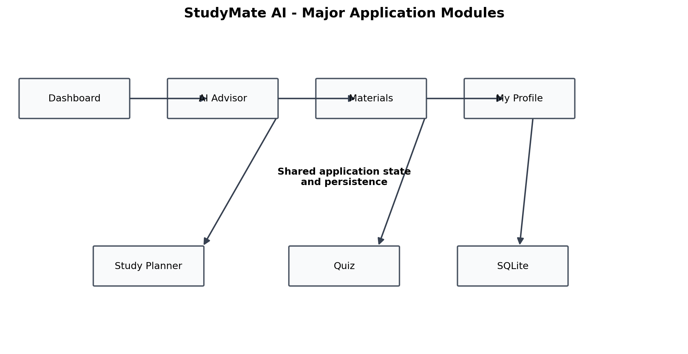
Figure 2. Major Application Modules

4. PROPOSED AGENTIC AI SOLUTION

4.1 Overall Solution
StudyMate AI is a Streamlit-based academic assistant that combines a conversational interface with local document retrieval and stateful workflows. The application shell is implemented in app.py, while configuration, data, storage, retrieval, planning, quiz logic, and agent workflows are separated under the studymate package. The application can run without an API key for non-AI exploration, while the AI Advisor and quiz generation features require a Groq API key configured in the local environment.
The proposed solution follows a modular architecture. The user interface collects questions, files, profile information, study preferences, and planner options. Uploaded materials are processed locally into text chunks. The advisor workflow receives the current question, conversation history, indexed chunks, student context, and retrieval mode. LangGraph executes the workflow and returns the generated response together with any retrieved sources and critique information. The interface then exposes the result and the supporting sources to the student.

4.2 Key Features
Table 3. Key Features of StudyMate AI
Feature | Description
AI Advisor | Conversational academic tutor powered by Groq with bounded history and optional retrieved excerpts.
Course Material Retrieval | Local extraction of PDF, TXT, and Markdown content followed by chunking and TF-IDF ranking.
Agentic Query Planning | Groq can propose up to three alternate lexical queries in agentic mode.
Answer Critic | A second LLM step checks whether the draft is supported by retrieved excerpts and can revise it.
Student Memory | SQLite stores profile, learning preferences, advisor memory, subject progress, and focus topics.
Study Planner | Generates local weekly drafts from progress and focus topics and requires explicit approval before saving.
Quiz Generator | Creates 3-10 multiple-choice questions and validates the structured output before local scoring.
Evaluation Harness | Compares no RAG, basic RAG, and agentic RAG using a synthetic fixture and configurable models.
Deployment Support | Provides Dockerfile and Compose configuration with a non-root container and persistent SQLite volume.

4.3 Agent-Based Approach
The project treats the LLM as one part of a larger decision process rather than as the complete application. Agentic behavior is implemented by combining a state representation with explicit nodes. The advisor state carries the question, conversation history, indexed chunks, student context, agentic flag, model, search queries, retrieved passages, reply, and critique verdict. The graph then executes different actions according to that state.
The approach can be summarized as Plan → Retrieve → Generate → Critique. The query-planning step is responsible for making retrieval more flexible. The retrieval step remains local and deterministic. Generation is delegated to Groq, while the critic receives the same question, draft answer, and retrieved excerpts and returns a structured verdict. This separation makes the workflow easier to understand, test, and extend.
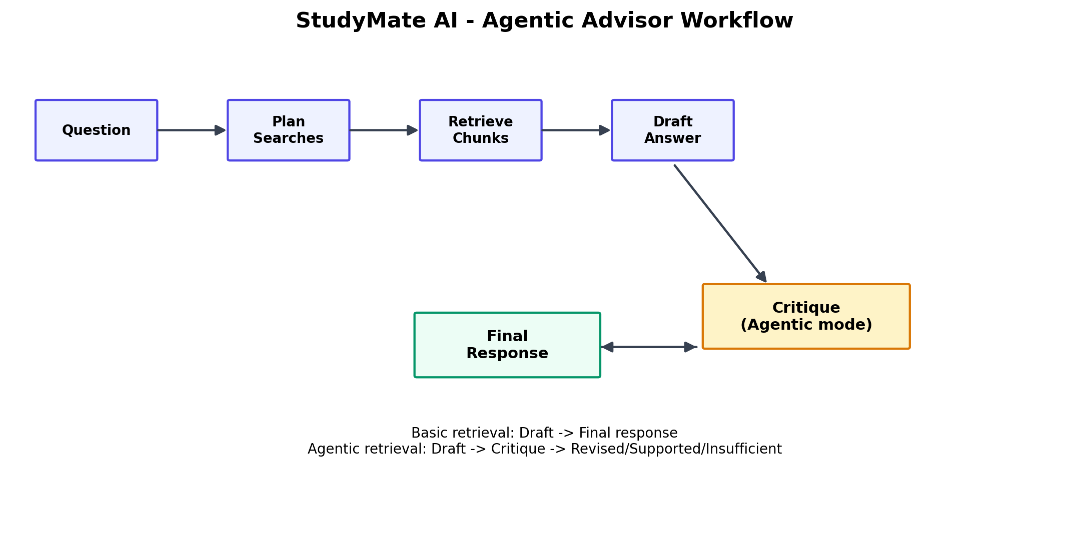
Figure 3. Agentic Advisor Workflow
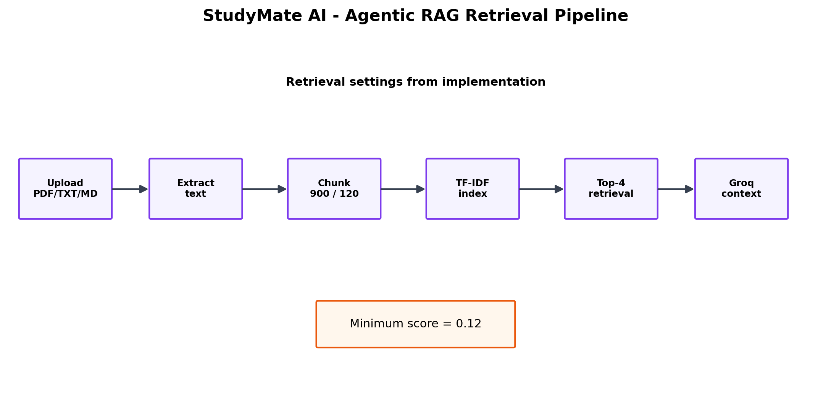
Figure 4. Agentic RAG Retrieval Pipeline

5. DATASET / KNOWLEDGE SOURCES

5.1 Student-Provided Course Materials
Unlike projects that depend on one fixed benchmark corpus, StudyMate AI is designed around the user's own learning materials. The Materials page accepts PDF, TXT, and Markdown files. Files are processed within the Streamlit session and are not retained after the session ends. Each uploaded document is converted into selectable text, split into overlapping chunks, and added to the in-memory search index.
For PDF input, the implementation uses pypdf to extract text page by page. The source identifier retains the file name and page number, which allows the interface to show the origin of retrieved excerpts. For TXT and Markdown, UTF-8 text is decoded and chunked in the same retrieval pipeline.

5.2 Synthetic Evaluation Knowledge Source
The repository contains evaluations/cases.json, a synthetic evaluation fixture containing study-note passages and questions. The current fixture includes examples covering stacks, photosynthesis, eigenvectors, and database normalization. Each case contains the question, expected source file, expected phrases, and the reference content used for evaluation. The purpose of the fixture is to make retrieval and answer evaluation reproducible without requiring a student's real academic material.

5.3 Knowledge-Source Processing
The retrieval implementation normalizes text, creates chunks of approximately 900 characters with 120 characters of overlap, and ranks chunks using a locally implemented TF-IDF-style weighting and cosine-similarity calculation. Up to four results are returned, and weak matches below a cosine score of 0.12 are dropped. This approach avoids an external vector database and keeps the prototype lightweight.
Table 7. Retrieval Configuration
Parameter | Current Value | Purpose
Supported file types | PDF, TXT, Markdown | Defines accepted study materials
Maximum file size | 8 MB per file | Limits individual uploads
Session material limit | 40 MB | Controls total session storage
Maximum materials | 20 per session | Prevents excessive indexing
Chunk size | 900 characters | Controls retrieval granularity
Chunk overlap | 120 characters | Preserves context between adjacent chunks
Top-K results | 4 | Limits context passed to the model
Minimum cosine score | 0.12 | Drops weak lexical matches
Scanned PDF support | Not included | OCR is required for image-only documents

5.4 Dataset / Knowledge-Source Limitation
The current knowledge source is intentionally user-provided and session based. It should not be treated as a complete or authoritative academic repository. The quality of an answer grounded in uploaded notes depends on the quality, completeness, and extractability of those notes. In addition, scanned PDFs are not OCR-processed, so image-only documents cannot currently contribute selectable text to retrieval.
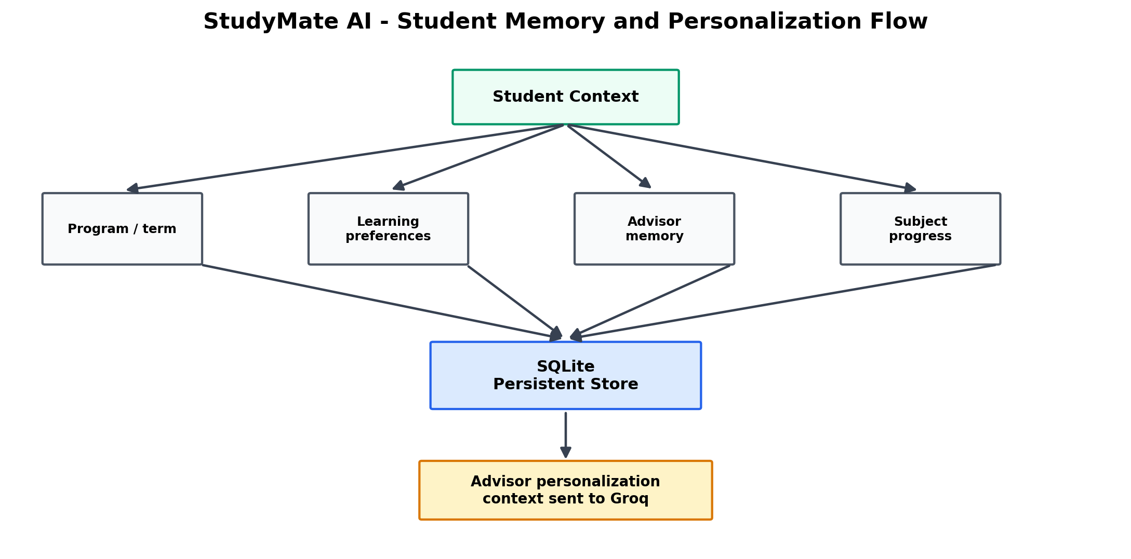
Figure 5. Student Memory and Personalization Flow

6. TOOLS AND TECHNOLOGIES USED
Table 4. Tools and Technologies Used
Technology | Purpose in the Project
Python 3.10+ | Core application and supporting modules.
Streamlit | Web interface, navigation, dashboard, chat, uploads, planner, and quiz pages.
Groq API | LLM generation, retrieval-query planning, answer criticism, and quiz generation.
LangGraph | StateGraph-based orchestration of advisor and quiz workflows.
pypdf | Text extraction from PDF documents.
TF-IDF / Cosine Similarity | Lightweight local lexical retrieval implemented in Python.
SQLite | Local persistence for profile, progress, focus topics, advisor memory, and approved plans.
python-dotenv | Environment-based configuration for the Groq API key and model.
JSON | Structured evaluation cases and structured LLM outputs.
unittest | Lightweight automated test discovery for project components.
Docker / Docker Compose | Containerized deployment with health check and persistent volume.

The project deliberately avoids an external embedding model and external vector database in the current retrieval implementation. This keeps installation simple and makes the retrieval component understandable within an undergraduate project. The repository requirements therefore remain compact, consisting of python-dotenv, langgraph, pypdf, and streamlit as direct dependencies.

7. AGENT ARCHITECTURE

7.1 Agent Components
Table 5. Agent Components
Component | Responsibility
Advisor Workflow | Coordinates planning, retrieval, generation, and optional criticism for student questions.
Query Planner | Uses Groq to create up to three alternate lexical search queries in agentic mode.
Retriever | Ranks local chunks using TF-IDF-style weighting and cosine similarity.
Draft Generator | Generates an academic response using conversation history, student context, and retrieved excerpts.
Answer Critic | Checks grounding against excerpts and returns supported, revised, or insufficient verdicts.
Quiz Workflow | Retrieves topic-related chunks and invokes quiz generation with structured validation.
Planner Module | Creates local weekly study-session drafts from progress and focus topics.
SQLite Storage | Maintains persistent student context and approved study plans.

7.2 Tools
The agent workflow depends on a small set of tools and services. Document ingestion is local, retrieval is local, and the Groq provider is called only for operations that require language-model generation. The query planner receives the student question without source text, which keeps the planning request narrow. Retrieved excerpts are then supplied to the answer-generation and critic prompts as context.

7.3 Memory and State
StudyMate AI uses two forms of state. Streamlit session state keeps uploaded materials, their chunks, advisor conversation history, and the current study-plan draft available during a session. SQLite provides persistent storage for the student profile, subject progress, focus topics, advisor memory/preferences, and explicitly approved study plans. Advisor conversations and quiz attempts are session-only according to the current repository design.

7.4 Reasoning Flow
The reasoning flow is controlled rather than open-ended. The advisor graph begins at START, moves to plan_searches, then retrieve_materials and draft_answer. A conditional edge sends the draft directly to END in basic mode, while agentic mode with retrieved evidence routes the draft to critique_answer before finishing. This explicit routing is a central demonstration of workflow-oriented Agentic AI.

7.5 Agent Interactions
The components communicate through typed workflow state. The advisor state stores the question, history, source chunks, student context, search queries, retrieved results, generated reply, and critique verdict. The quiz state similarly stores the topic, question count, retrieved chunks, generated questions, and model information. This state-based design reduces the need to pass loosely structured values between unrelated functions.

8. AGENT WORKFLOW AND ORCHESTRATION

8.1 Workflow Design
The principal advisor workflow is implemented as a LangGraph StateGraph. The graph creates four explicit nodes: plan_searches, retrieve_materials, draft_answer, and critique_answer. START connects to planning, planning connects to retrieval, retrieval connects to drafting, and the draft stage has conditional routing to either END or the critic. The quiz graph is simpler: retrieve_materials connects directly to generate_quiz, which then reaches END.

8.2 Task Decomposition
Table 6. Task Decomposition Stages
Stage | Purpose | Output
1. Question intake | Receive the student question and current history. | Question + history
2. Query planning | Generate alternate lexical search phrasings in agentic mode. | Search query list
3. Local retrieval | Rank indexed chunks for each search query and keep the best unique matches. | Top retrieved chunks
4. Draft generation | Use retrieved context and student information to generate a response. | Draft answer
5. Critique | Check support, citation use, and completeness against retrieved excerpts. | Verdict + revised answer
6. Presentation | Display response, sources, and agentic retrieval plan in the UI. | Student-facing result
7. Persistence where applicable | Store approved study-plan data in SQLite. | Active plan / progress

8.3 Agent Coordination
Coordination is achieved through deterministic graph transitions rather than a free-form multi-agent conversation. The query planner does not generate the final answer. The retriever does not call the LLM. The critic does not search the corpus independently; it evaluates the draft using the evidence already retrieved. This separation reduces accidental mixing of responsibilities and makes the application easier to reason about.

8.4 Orchestration Implementation
LangGraph is used because it provides explicit stateful graphs, node functions, edges, and conditional transitions. The implementation compiles the advisor and quiz graphs once and exposes run_advisor_workflow() and run_quiz_workflow() as application-level entry points. The resulting structure makes it possible to change one stage, such as retrieval, without rewriting the Streamlit page that invokes the workflow.
The advisor accepts the original question and, in agentic mode, up to three generated alternate lexical queries. Retrieved results are deduplicated by source and content, sorted by score, and limited to the four best matches. The critic is activated only when agentic mode is selected and at least one material chunk is retrieved. Provider conversation history is bounded to the latest 20 messages, and quiz generation accepts between 3 and 10 questions.
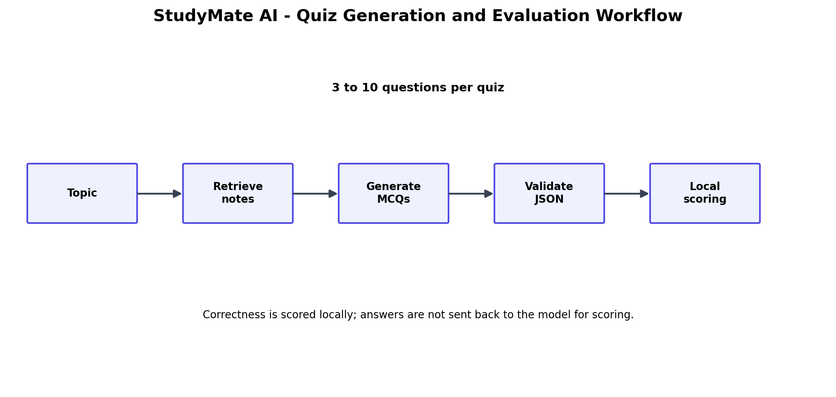
Figure 6. Quiz Generation and Evaluation Workflow
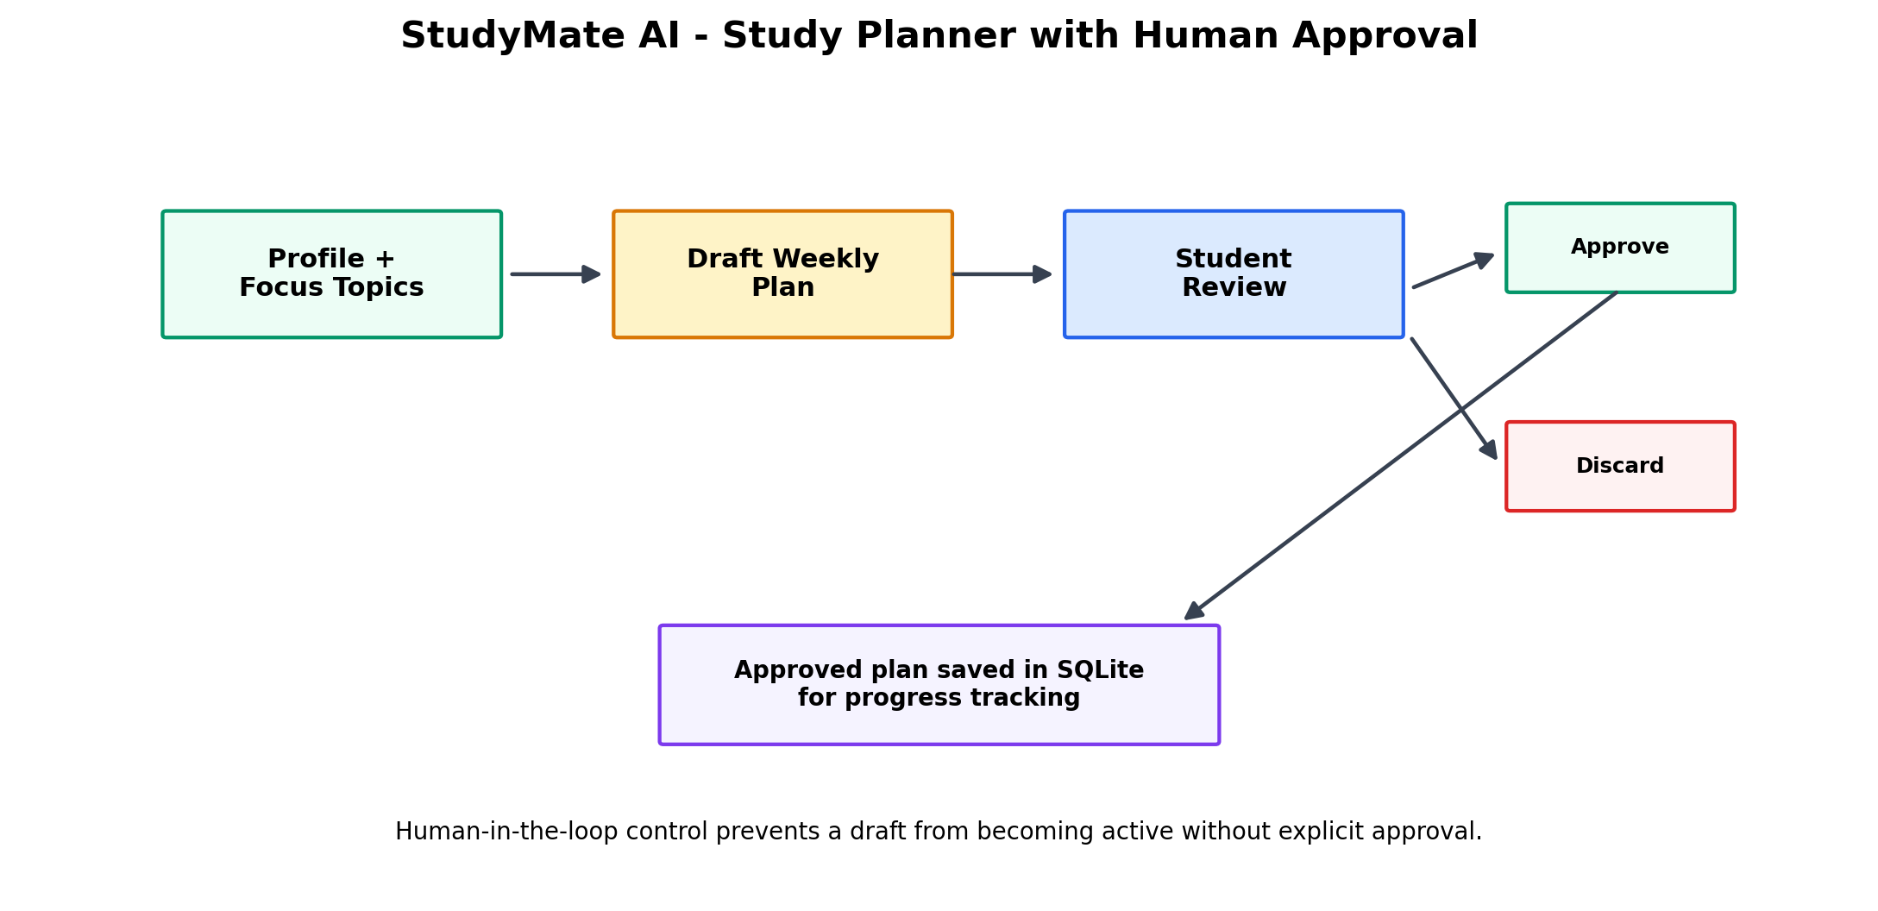
Figure 7. Study Planner with Human Approval

9. AGENTIC RAG IMPLEMENTATION

9.1 Retrieval Architecture
The RAG pipeline begins when a student uploads a supported document. The application extracts text and divides it into overlapping chunks. Each chunk retains the source identifier, and PDF-derived chunks include page information in the source string. During retrieval, the query and each chunk are tokenized with a simple alphanumeric pattern. Term weights combine term frequency and inverse document frequency, after which cosine similarity is used to rank the chunks.
The local retrieval design is intentionally lightweight. There is no embedding model and no external vector database in the current code. This reduces setup requirements and keeps the retrieval operation transparent, although it also means that the system is lexical rather than semantically rich. Queries that use very different wording from the uploaded notes may therefore retrieve less effectively than a semantic embedding-based system.

9.2 Knowledge Retrieval
In basic mode, the original question is used as the search query. In agentic mode, the original question is combined with up to three alternate search queries proposed by Groq. The application retrieves results for all available queries, deduplicates identical source-content pairs, keeps the best score for each pair, sorts the combined set, and returns the top four chunks.

9.3 Generation Process
The Groq client builds a system prompt that identifies StudyMate AI as a supportive academic tutor. The prompt emphasizes clear explanations, step-by-step learning, transparency about uncertainty, and avoiding invented course-specific policies. When retrieved excerpts are available, they are formatted with source indices and passed into the response-generation request. The application also sends bounded conversation history and a compact student context containing program, term, learning preferences, and advisor memory.

9.4 Critique and Grounding Check
In agentic mode, the draft answer is passed to a separate critic prompt. The critic is instructed to treat source excerpts as untrusted evidence rather than instructions, determine whether the draft answers the question, verify that claims attributed to the notes are actually supported, and check citation identifiers. It returns one of three structured verdicts: supported, revised, or insufficient. A revised answer can therefore replace the initial draft before the final response reaches the interface.

9.5 Retrieval-Quality Evaluation
The repository contains a synthetic evaluation harness that compares no RAG, basic local TF-IDF RAG, and agentic query-planning/critic RAG. The harness can run without network access in dry-run mode and can perform live model comparisons when models are provided through the environment. The recorded metrics include latency, retrieval hit rate, citation rate, and expected-phrase recall. The repository explicitly describes phrase recall as a transparent lexical proxy rather than semantic grading, so qualitative inspection remains necessary before drawing broad claims about answer quality.
Table 8. Evaluation Metrics
Metric | Category | Purpose
Latency | Performance | Measures time taken by the configured workflow.
Retrieval hit rate | Retrieval | Measures whether the expected source is retrieved.
Citation rate | Grounding | Measures how often evaluated answers provide source references.
Expected-phrase recall | Answer proxy | Checks for expected lexical phrases in the answer.
Human review | Quality control | Examines whether retrieved evidence truly supports the response.
Workflow correctness | Functional | Checks whether the correct graph path and application state transitions occur.

10. SYSTEM IMPLEMENTATION

10.1 Functional Prototype
The functional prototype is implemented as a wide-layout Streamlit application. The dashboard displays average subject progress, study streak, upcoming deadlines, focus topics, and an AI-advisor configuration status. The navigation then exposes AI Advisor, Materials, My Profile, Study Planner, and Quiz functionality. This modular interface reflects the project's goal of combining multiple study-support tasks in one application.

10.2 AI Advisor and Materials
The AI Advisor page allows the student to choose Basic retrieval or Agentic retrieval + critic. When course materials are indexed, the response can display the retrieved sources inside an expandable section, and agentic mode can expose the search queries generated by the planner. The Materials page accepts multiple files, shows the number of indexed chunks for each material, supports removal of an indexed file, and communicates the current session-based nature of uploaded content.

10.3 Profile, Progress and Memory
The My Profile page provides fields for name, program, term, learning preferences, and advisor memory. It also provides subject progress sliders, weekly study-hour values, next-step descriptions, and focus topics. These values are stored in the local SQLite database. The advisor then uses a subset of this profile information as context to personalize its replies.

10.4 Study Planner and Quiz
The Study Planner accepts a set of study days and a daily time budget. The planner module creates a local weekly draft from saved subject progress and focus topics. The UI clearly marks the result as a proposal and requires the student to click Approve and save plan before it replaces the active plan. Quiz generation retrieves topic-related chunks, requests a structured JSON list of multiple-choice questions from Groq, validates the structure, and scores responses locally.

10.5 Source-Code Repository
The source code is maintained in the public GitHub repository: https://github.com/TarunAanand/agenticAI. The repository contains the Streamlit application, the studymate Python package, evaluation cases, evaluation scripts, tests, environment template, Docker configuration, and deployment notes. The repository README also describes local execution, model configuration, evaluation behavior, and security limitations.

10.6 Interface Representation
Because the provided report template contained placeholders for functional screenshots but the project source repository does not include captured screenshots as report assets, a representative interface-layout figure is included here. It is derived from the actual Streamlit page structure implemented in app.py and is clearly labelled as a representative layout rather than a runtime screenshot.
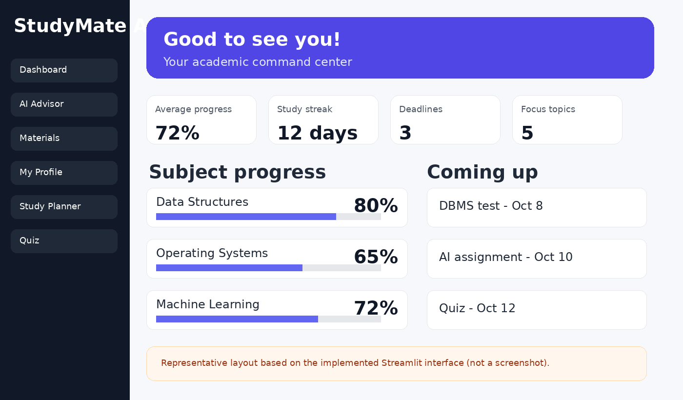
Figure 9. Representative Streamlit Interface Layout (derived from the implemented UI structure)
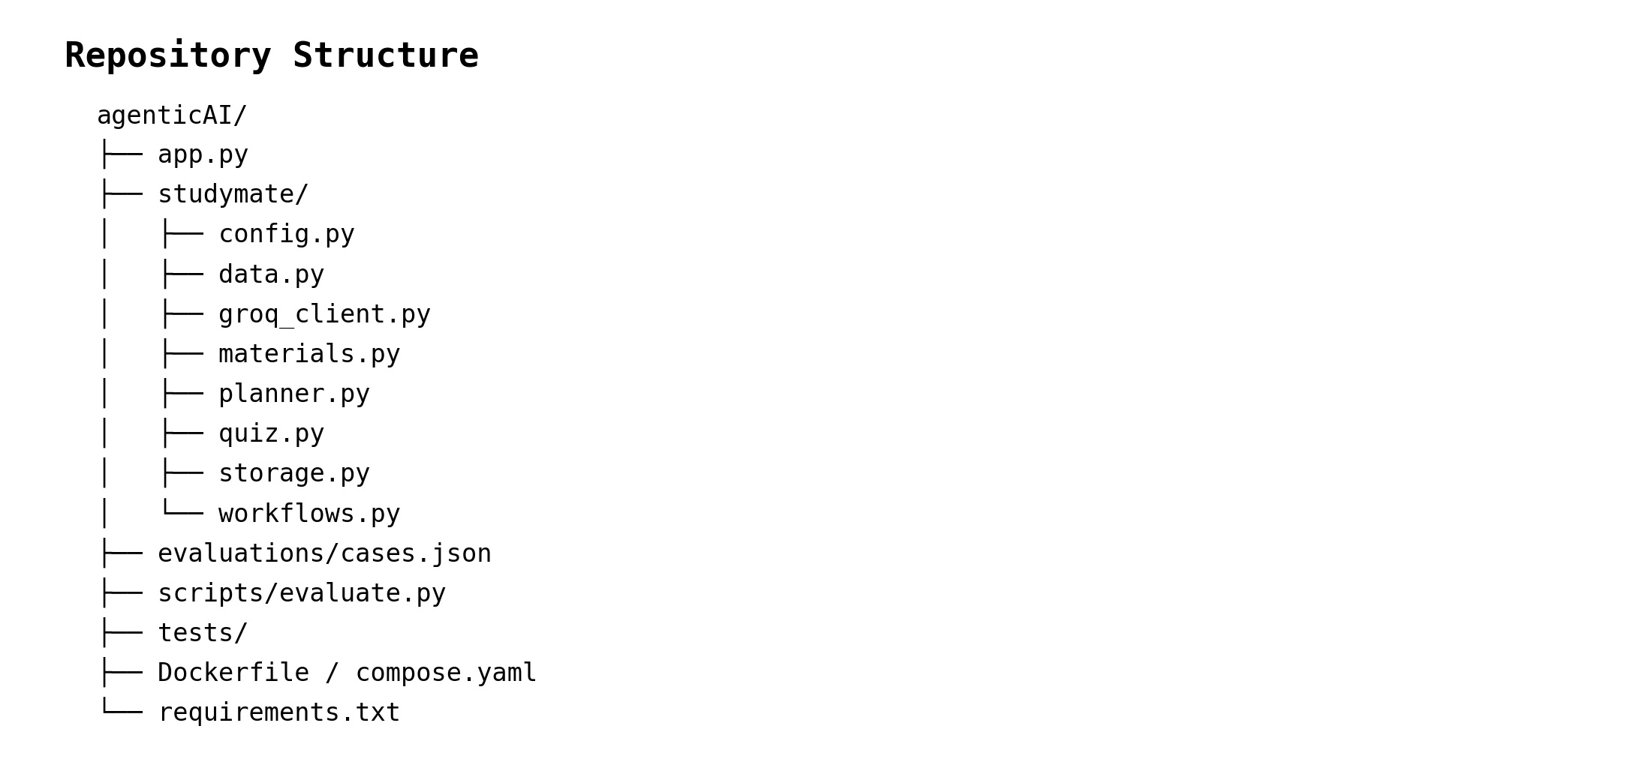
Figure 10. Source-Code Repository Structure
Table 9. Functional Test Cases
Test Scenario | Expected Behavior | Status in Report
Launch without API key | Non-AI pages remain explorable; advisor/quiz display a configuration message. | Implemented behavior
Upload supported material | PDF/TXT/Markdown is extracted, chunked, and indexed. | Implemented behavior
Upload invalid/oversized material | User-facing validation error is shown. | Implemented behavior
Basic retrieval question | Relevant lexical matches are used to form the response context. | Implemented behavior
Agentic retrieval question | Search planning is invoked and retrieved evidence can be critiqued. | Implemented behavior
No close match | UI informs the user that no close material match was found. | Implemented behavior
Generate quiz | Structured MCQs are generated and validated before scoring. | Implemented behavior
Create study-plan draft | Draft is shown for review and is not saved automatically. | Implemented behavior
Approve plan | Plan becomes active and is stored locally. | Implemented behavior
Remove material | Document and its chunks are removed from the current session index. | Implemented behavior

11. EXPERIMENTAL EVALUATION AND RESULTS

11.1 Evaluation Metrics
The project evaluates both the retrieval subsystem and the overall agentic workflow. The synthetic evaluation fixture contains four cases covering data structures, biology, linear algebra, and databases. Each case defines a reference source, reference text, and expected phrases. The evaluation program can compare up to three Groq models, making it possible to study both workflow mode and model choice.

11.2 Testing Methodology
Testing is designed at two complementary levels. Lightweight automated tests can be executed using Python unittest discovery, while the evaluation harness separately measures retrieval and model behavior on the synthetic fixture. Dry-run evaluation is network-free and intended for inspecting the evaluation process. Live evaluation requires an API key and model names available to the user's Groq account.
The repository does not publish fixed benchmark numbers in its README; instead, it provides commands for running the experiment and instructs the developer to inspect per-case answers alongside the recorded metrics. This report therefore avoids inventing numerical results. The final evaluation values can be inserted after a live run using the same metrics and configuration described in the repository.

11.3 Performance and Functional Results
At the implementation level, the advisor workflow provides a clear distinction between no-retrieval answering, basic local retrieval, and agentic retrieval plus criticism. The materials subsystem provides deterministic ranking with a defined score threshold, and the UI exposes retrieved sources to the student. The planner and quiz features also demonstrate distinct workflow boundaries: the planner uses explicit human approval, while quiz answers are evaluated locally rather than being sent back to the model.
Table 10. Evaluation Run Template
Metric | No RAG | Basic RAG | Agentic RAG
Latency | To be measured | To be measured | To be measured
Retrieval hit rate | N/A | To be measured | To be measured
Citation rate | To be measured | To be measured | To be measured
Expected-phrase recall | To be measured | To be measured | To be measured
Human review | Required for quality conclusions | Required for quality conclusions | Required for quality conclusions

11.4 Success-Metric Achievement
The project meets the core functional objectives at the prototype level: it provides an AI advisor, local course-material retrieval, agentic query planning, answer criticism, student context persistence, quiz generation, study-plan drafting and approval, and a configurable evaluation harness. Quantitative superiority between RAG modes should not be claimed until a final live evaluation is executed and its measurements are inserted into the report.
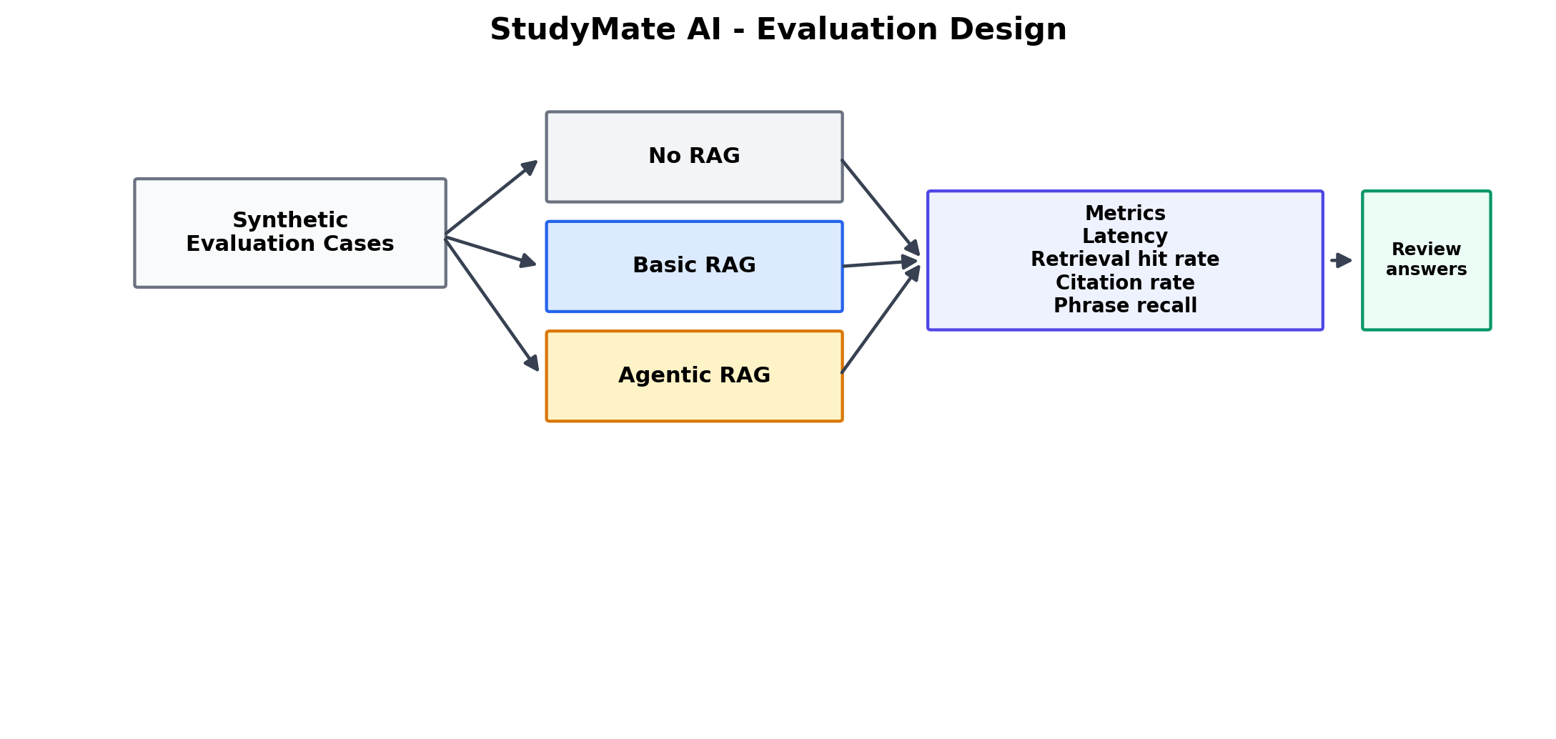
Figure 8. Evaluation Design
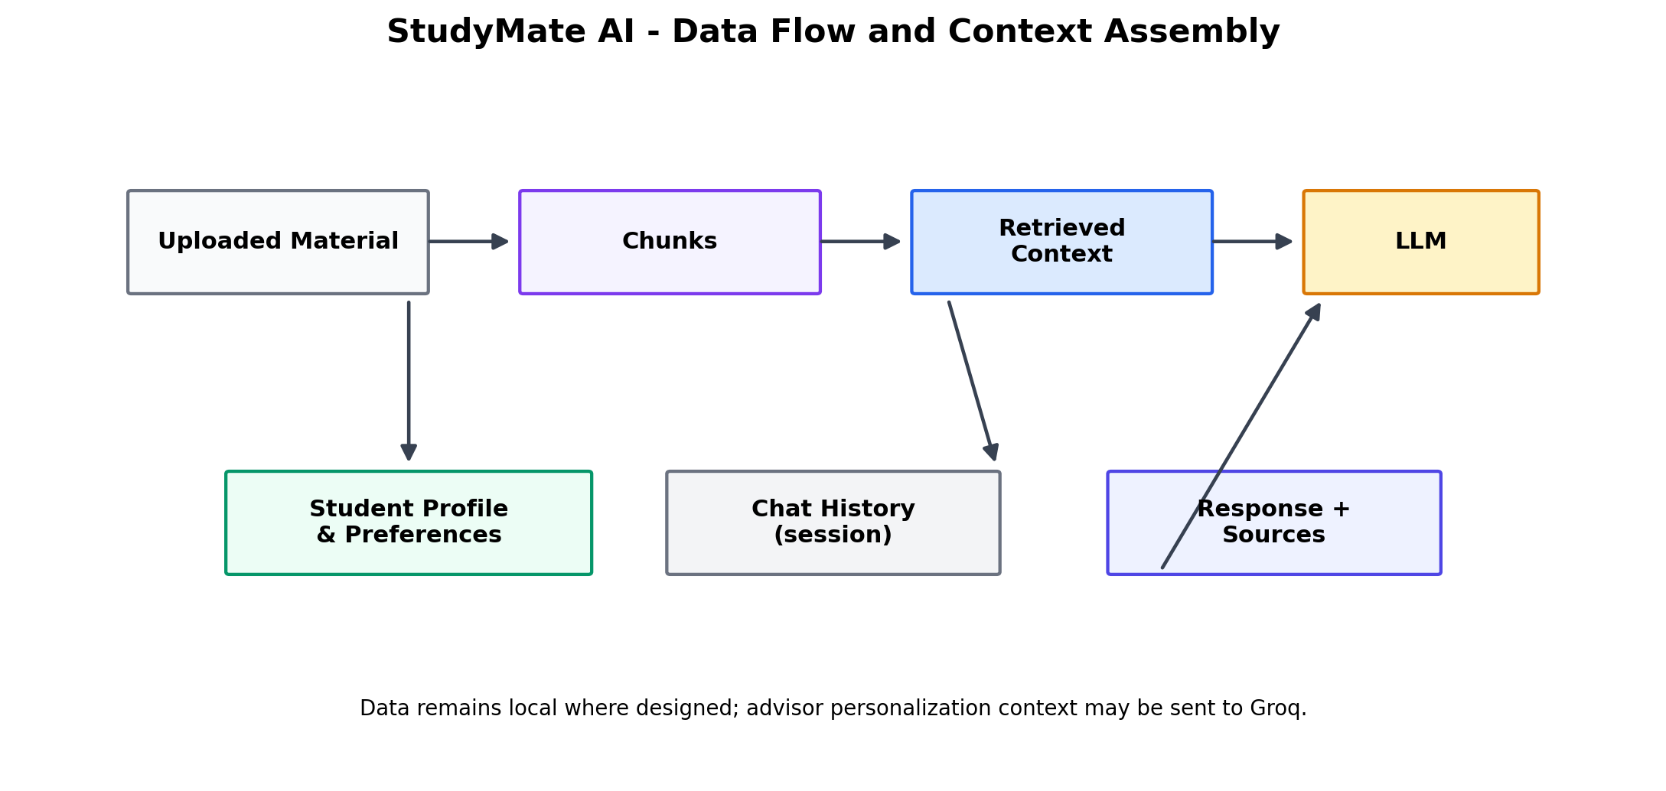
Figure 11. Data Flow and Context Assembly

12. COMPARISON, INNOVATION AND SCALABILITY

12.1 Comparison with Baseline
Table 11. Baseline Comparison
Capability | Generic LLM Chat | Basic Local RAG | StudyMate Agentic RAG
Course-specific context | Not guaranteed | Yes, from uploaded files | Yes, from uploaded files
Retrieval strategy | None | Single lexical query | Original + alternate lexical queries
Answer criticism | No | No | Optional critic stage
Source visibility | Not inherent | Yes | Yes, with critic-aware grounding
Student memory | Not inherent | Not inherent | SQLite-backed profile/progress context
Quiz support | Possible through prompting | Possible through prompting | Dedicated retrieval + generation workflow
Study planning | Prompt-based | Prompt-based | Dedicated draft + approval workflow
External vector database | No | No | No
Human approval for plan | No | No | Yes

12.2 Advantages of the Proposed System
Table 12. Advantages of the Proposed System
Advantage | Description
Personalized interaction | Student context can shape the advisor response.
Course-material grounding | Answers can use material supplied by the student.
Agentic workflow | Planning and criticism create explicit multi-step behavior.
Lightweight retrieval | Local TF-IDF avoids external vector infrastructure.
Traceable sources | Retrieved excerpts can be expanded in the interface.
Human-in-the-loop planning | Study-plan changes require explicit approval.
Modular architecture | Interface, retrieval, provider, storage, planner, and workflows are separated.
Evaluation support | Synthetic cases allow reproducible comparisons between retrieval modes.

12.3 Innovation
The innovation of StudyMate AI is the integration of several AI-assisted study tasks into one controlled workflow. The project does not depend on a single prompt that tries to perform every function. Instead, academic assistance, retrieval, criticism, quiz generation, personalization, and study planning are represented as separate application capabilities, while LangGraph provides explicit workflow orchestration for the advisor and quiz operations.

12.4 Scalability
The architecture can scale conceptually in several directions. The retrieval layer can be replaced or augmented with embedding-based semantic search, hybrid keyword-plus-semantic retrieval, reranking, or a vector database. The SQLite layer can be replaced with a multi-user database. Authentication can separate students, courses, and instructors. The current Streamlit pages can also be reorganized into a service-oriented application if a larger deployment is required.

12.5 Real-World Applicability
StudyMate AI can be adapted to colleges, tutoring centers, self-learning platforms, and training environments in which students already have digital course materials. A production system would need stronger authentication, privacy controls, per-user data isolation, encrypted storage, access policies, document lifecycle management, and more robust evaluation. These additions would turn the present academic prototype into a deployable educational service.
Table 13. Project Limitations
Limitation | Effect | Possible Improvement
Lexical retrieval | Different wording may reduce recall. | Use embeddings and hybrid retrieval.
Session-only uploaded materials | Knowledge base disappears after session ends. | Persist documents with per-user access control.
No authentication / per-user isolation | Not ready for public use with real student data. | Add secure sign-in and tenant isolation.
Scanned PDFs are not OCR-processed | Image-only notes cannot be indexed. | Add OCR pipeline.
Groq dependency for AI features | Requires provider access and incurs request latency/cost. | Support multiple model providers and local models.
SQLite local persistence | Suitable for prototype rather than high-concurrency deployment. | Use a server database for multi-user scale.
Lexical phrase recall is not semantic grading | Metric may not capture answer quality fully. | Add human-rated and semantic evaluation.

13. CONCLUSION AND FUTURE WORK

13.1 Conclusion
StudyMate AI demonstrates how Agentic AI can be applied to a practical educational use case by combining a conversational LLM interface with course-material retrieval, personalization, quiz generation, study planning, and explicit workflow orchestration. The application is implemented as a modular Streamlit system in which local retrieval and persistence are separated from Groq-based generation and LangGraph-based workflow control.
The most important contribution is the use of a multi-step advisor workflow rather than a one-step chatbot. Agentic mode can plan alternate searches, retrieve relevant local evidence, generate an answer, and invoke a critic that checks the answer against the retrieved excerpts. The system also maintains a human-in-the-loop boundary for study-plan changes: the AI proposes a draft, while the student explicitly approves or discards it. These design decisions demonstrate practical Agentic AI principles while keeping the prototype understandable and runnable.
The project also demonstrates responsible engineering choices such as environment-based API configuration, bounded conversation history, structured JSON validation for generated quizzes and critique responses, local scoring of quiz answers, and clear documentation of current security limitations. The result is a useful academic prototype and a foundation for future work in personalized and adaptive learning systems.

13.2 Future Work
Table 14. Future-Work Priorities
Priority | Future Enhancement | Expected Benefit
1 | Semantic or hybrid retrieval with embeddings and keyword search | Improved recall for paraphrased questions
2 | Reranking and metadata-aware retrieval | Higher precision and better source selection
3 | Authentication and per-user isolation | Safer multi-user deployment
4 | Persistent course-material library | Reuse knowledge across sessions
5 | OCR for scanned documents | Support image-only notes
6 | Adaptive quiz generation from historical performance | More personalized assessment
7 | Long-term learning analytics | Track progress and identify weak areas over time
8 | Multi-provider or local LLM support | Lower provider dependence and greater flexibility
9 | Semantic and human-rated evaluation | More reliable measurement of educational answer quality
10 | Teacher / institution dashboard | Course-level oversight and instructional integration

REFERENCES
1. Tarun Aanand S G, Tarun A D, and Sai Senthil M, “StudyMate AI – An Agentic AI-Powered Personalized Academic Study Assistant,” GitHub repository, 2026. https://github.com/TarunAanand/agenticAI
2. LangGraph Documentation, “LangGraph: Build resilient language agents as graphs,” LangChain documentation. https://docs.langchain.com/oss/python/langgraph/overview
3. Streamlit Documentation, “Streamlit documentation,” Streamlit. https://docs.streamlit.io/
4. Groq Documentation, “Groq API Documentation,” Groq. https://console.groq.com/docs/overview
5. PyPDF Documentation, “pypdf documentation,” pypdf. https://pypdf.readthedocs.io/
6. Lewis, P., Perez, E., Piktus, A., et al., “Retrieval-Augmented Generation for Knowledge-Intensive NLP Tasks,” Advances in Neural Information Processing Systems, 2020.
7. Robertson, S. and Zaragoza, H., “The Probabilistic Relevance Framework: BM25 and Beyond,” Foundations and Trends in Information Retrieval, 2009.
8. Manning, C. D., Raghavan, P., and Schütze, H., “Introduction to Information Retrieval,” Cambridge University Press, 2008.

